Practical No 7

Aim: Write a Program for Web Feed.

Theory:

* On the [World Wide Web](https://en.wikipedia.org/wiki/World_Wide_Web), a **web feed** (or **news feed**) is a data format used for providing users with frequently updated content. Content distributors [*syndicate*](https://en.wikipedia.org/wiki/Web_syndication) a web feed, thereby allowing users to *subscribe* a channel to it.
* Making a collection of web feeds accessible in one spot is known as *aggregation*, which is performed by a [news aggregator](https://en.wikipedia.org/wiki/News_aggregator). A web feed is also sometimes referred to as a *syndicated feed*.
* A typical scenario of web-feed use might involve the following: a content provider publishes a feed link on its site which [end users](https://en.wikipedia.org/wiki/End_user) can register with an [aggregator](https://en.wikipedia.org/wiki/Feed_aggregator) program (also called a *feed reader* or a *news reader*) running on their own machines; doing this is usually as simple as dragging the link from the [web browser](https://en.wikipedia.org/wiki/Web_browser) to the aggregator.
* When instructed, the aggregator asks all the servers in its feed list if they have new content; if so, the aggregator either makes a note of the new content or downloads it. One can schedule aggregators to check for new content periodically.

Procedure:

Step 1: open notepad and type following code

<?xml version="1.0" encoding="UTF-8"?>

<rss version="2.0">

<channel>

<title>W3Schools Home Page</title>

<link>https://www.w3schools.com</link>

<description>Free web building tutorials</description>

<item>

<title>RSS Tutorial</title>

<link>https://www.w3schools.com/xml/xml_rss.asp</link>

<description>New RSS tutorial on W3Schools</description>

</item>

-<item>

<title>XML Tutorial</title>

<link>https://www.w3schools.com/xml</link>

<description>New XML tutorial on W3Schools</description>

</item>

</channel>

</rss>

Step 2: save the following code with .xml extension **(For example rss.xml)**

STEP 3: Open the software visual studio 2010 Do the following

File ̶ ˃ new ̶ ˃ website ̶ ˃ visual C# ̶ ˃ ASP.NET website ̶ ˃ Ok

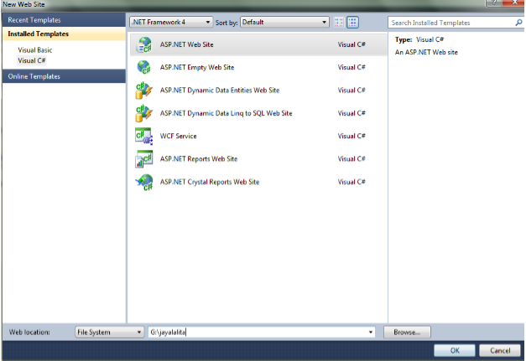

STEP 4: Now copy that rss file which was saved with .xml extention inside your website folder

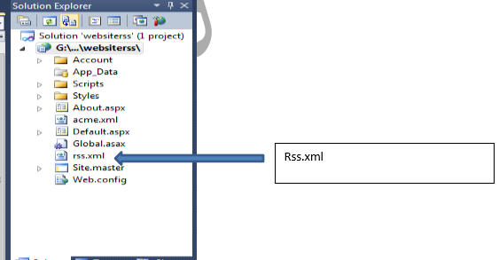

STEP 5: Type this <p>here is ur <a href="rss.xml">feed</a>.</p>

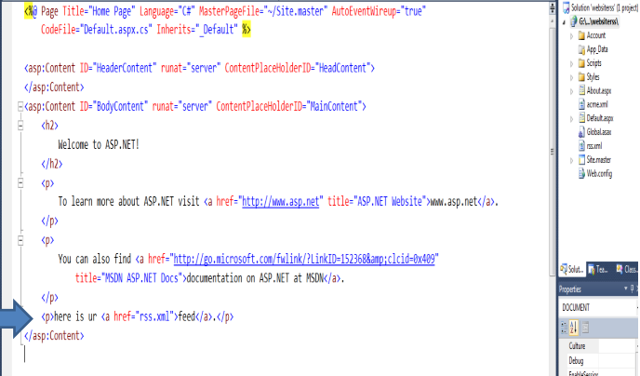

STEP 6: Run the page

STEP 7: output

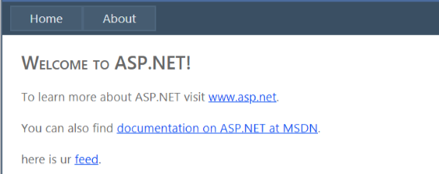

Click On feed

STEP 8: The RSS web feed as output

